ATTENTION ALL STUDENTS: IT’S TIME TO GET READY FOR 2022 MAURICE HAWK VIRTUAL
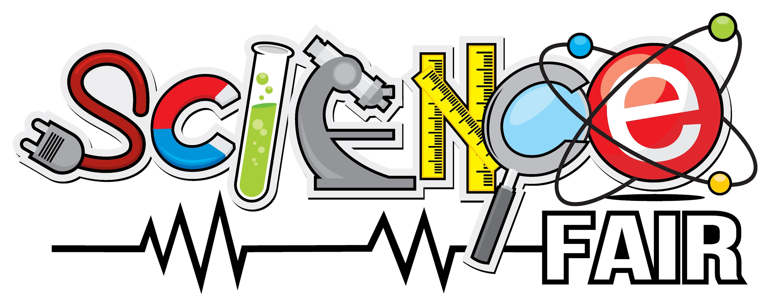
VIRTUAL SCIENCE FAIR DATE: Saturday, February 12th, 2022, 10 am - 12 pm
REGISTRATION OPENS ONLINE ONLY: Wednesday, January 12th
REGISTRATION DEADLINE: Sunday, January 26th, 11:30pm

Are you a budding scientist, biologist, chemist, physicist, programmer, engineer or just someone who has a lot of questions that start with how, why or what if? If you are, then we hope you’ll sign up to be a part of the Maurice Hawk Virtual Science Fair!

Come up with a question about astronomy, robotics, AI, natural science and the workings of our planet or maybe what happens when baking soda and vinegar hang out together and conduct some research, design some experiments and record your findings and conclusions. Then put it all together in a colorful presentation to share with everyone at the Science Fair.

You can sign up by yourself or with a team of 1 or 2 friends or siblings and then it’s time to get to work, asking questions, exploring possibilities, and finding answers! Remember to follow COVID safety guidelines if doing as a team.

Format of Virtual Science Fair:

Step 1: Register online using registration links.
Registration opens on Wednesday, January 12th online at hawkpta.org. The fee is $3.00 per team (plus a $0.99 processing fee).
Registration is online only at our website, HawkPTA.org

Step 2: Make a video of your Project Presentation and upload the video following the guidelines. Guidelines will be emailed upon successful registration.

Deadline to upload the videos: February 6th, 11:30 pm.

Step 3: On the day February 12th, Teachers and Students along with the Principle and other special guests will join the Zoom call to view and discuss the projects. Zoom call details will be emailed 2 days prior to the event.

REMEMBER: You should be able to do most of the work on your project on your own but it’s ok to talk to your teacher or a parent if you need some help.

If you have any questions, please have your parents send an e-mail to sciencefair@hawkpta.org

We look forward to seeing you!

PARENT INFORMATION REGARDING
THE MAURICE HAWK VIRTUAL SCIENCE FAIR
Dear Parents,
Looking for ideas or guidelines about how to help your child so he or she has a successful, fun and safe project for the fair? Just continue reading below!
A Science Fair project attempts to answer a question posed by your child. It requires research, organization and the desire to find answers to real-life questions. It does not need to be complicated or complex in nature. The more focused and specific the question the scientist asks, the easier it can be to research and present the findings. Therefore, the first thing a young scientist needs to do is select an appropriate topic and ask an appropriate scientific question. You can help guide your child in this process keeping in mind that the goal is to make sure this is a project, and a process that is driven by your child’s curiosity and not the parent’s desire to have a perfect presentation. When you register, let us know which category of project the team is creating:

- Experiment
- Research
- Apparatus
- Demonstration
- Collection

SAFETY:
Be sure to select a project that does not risk harm to your child or anyone. (or thing) else. DO NOT work with dangerous chemicals, fire, explosives, poisonous reptiles, or water with electricity.

The Science Fair is meant to be a fun experience for your child and one that encourages their curiosity with the world around them. If you need some help getting ideas of age-appropriate topics, check out some of the links below (or check out the ever-popular Pinterest!) to help get your child started thinking about what he or she might want to explore for the Science Fair.

www.sciencebuddies.org
http://www.hometrainingtools.com/a/science-fair-projects-for-elementary
http://www.education.com/science-fair/elementary-school/?page=2
www.all-science-fair-projects.com
www.sciencebob.com/sciencefair/ideas.php

If you have any questions, please e-mail us at sciencefair@hawkpta.org
Thank you!

PTA Science Fair Committee Chairs
Alan Wan
Daria Bekker
Geetha Vedantha Desikan
Jimit Doshi
Neha Singh

