Hello, Team MH!
Here are the pictures of the t-shirt design for Team MH (under the name Hawk/Wicoff Elementary Schools on the Autism Speaks website). If you are interested in ordering a t-shirt, either for the walk or to wear to school, please complete the form and send it in with your child by Monday, 9/24.
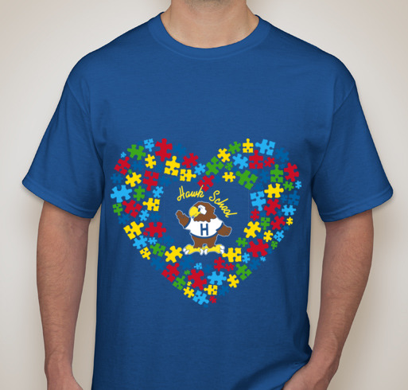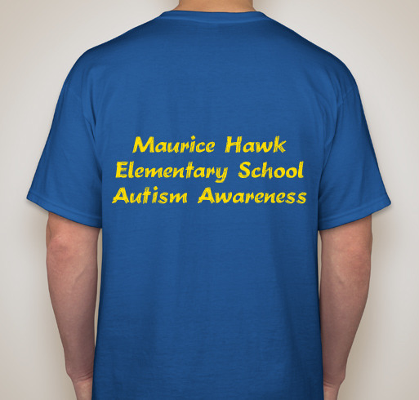
The price of the t-shirt is based upon the number of t-shirts ordered (10 shirts = $30 each, 15 shirts = $27 each, 20 shirts = $25 each). We will email those that are interested to let you know the pricing. For any size larger than XL, there will be an additional charge.
Parent Name/Email address: ____________________________________________________________
Student/Teacher names: _______________________________________
Adult Sizes:
XS | S | M | L | XL | 2X | 3X | 4X

Child Sizes:
XS | S | M | L | XL

